**Automatic Clothes Segregator**

Sanika Deshpande1, a**,** Yash Dhond2,b **,**Anuj Gavhane3,c and

Suvarna Gaikwad4,d

Department of Electronics and Telecommunication Engineering,Pimpri Chinchwad College of Engineering,Nigdi Pradhikaran ,Pune ,India.

[asanika.deshpande21@pccoepune.org](mailto:asanika.deshpande21@pccoepune.org)

, [byash.dhond21@pccoepune.org](mailto:byash.dhond21@pccoepune.org),

[canuj.gavhane21@pccoepune.org](mailto:canuj.gavhane21@pccoepune.org),

[dsuvarna.gaikwad@pccoepune.org](mailto:dsuvarna.gaikwad@pccoepune.org)

**Abstract**

In today's era, washing machines are used mainly for cloth washing. Both coloured and white clothes, if washed together there, are possible to mix colours. Colour segregation is needed for washing machines to avoid such situations. The proposed system introduces an Automatic Clothes Segregator that employs the TCS3200 colour sensor and Arduino Uno microcontroller as fundamental components. The Automatic clothes segregator operates on the TCS3200 sensor and detects the colour of incoming garments, converting light intensity into digital signals processed by the Arduino Uno controller. Upon analysis, the controller initiates segregation, directing garments to designated compartments based on colour. Rigorous testing validates the system's reliability and accuracy, showcasing high precision in colour detection and segregation while accommodating a broad spectrum of colours. The proposed system holds significant promise for industries reliant on efficient sorting processes, including laundry services, garment manufacturing, and retail. Integrating advanced sensor technology and microcontroller systems is a transformative step towards automation, promising heightened productivity and resource optimization across diverse operational contexts.

**Keywords:**Arduino nano, Automation, Color Detection, Segregation, TCS3200

**Introduction**

This project presents a novel solution called the Automatic Clothes Segregator (ACS), which is aimed at optimizing the sorting process of garments based on their colours. Utilizing the precision of the TCS3200 colour sensor alongside the flexibility of the Arduino Uno microcontroller, the ACS automates the identification and separation of clothes based on their distinct colours. Adhering strictly to IEEE standards, the system ensures the dependability and precision of its functions. The ACS holds significant promise for transforming industries reliant on efficient sorting methods, including laundry services, garment manufacturing, and retail, offering enhanced productivity and resource utilization through integrating advanced sensor technology and microcontroller platforms.

**Literature Survey**

The Automatic Clothes Segregator (ACS) employs a TCS3200 color sensor and Arduino Uno microcontroller to segregate clothes based on their color [1]. Numerous studies have demonstrated the viability of using Arduino and the TCS3200 for color sorting in diverse applications, such as sorting industrial parts, tomatoes, and educational aids [1, 2, 4, 10, 12, 16].

The potential applications of the ACS span across several industries, including laundry services, garment manufacturing, and retail [1, 14, 16]. Automatic sorting can significantly enhance efficiency, reduce human error, and potentially mitigate damages caused by color bleeding during washing [1, 18]. This versatility suggests that the ACS could be a valuable tool in streamlining processes and improving the quality of services in these sectors.

The project utilizes established components, it presents a novel application by focusing specifically on clothes segregation [13, 14, 17]. Existing studies often address sorting in broader contexts such as object recognition or industrial automation. This targeted approach towards clothes segregation adds a distinctive dimension to the project's contribution to the field of automated sorting systems.

Recognizing the limitations like sensitivity to ambient light and the necessity for regular sensor calibration [1, 13, 17] future studies could explore the integration of advanced sensor technologies and machine learning algorithms. These enhancements could significantly improve color detection and classification accuracy, thereby boosting the overall effectiveness of the ACS [1, 13, 17].

**Methodology**

The process flow of the proposed system is shown in Fig.1.This figure explains the working flow of the model and the work of all components to carry the mechanism of clothes segregation.



Fig. 1. Process flow of Automated Clothes Segregator

This automated system commences by identifying incoming clothes and employing a TCS3200 colour sensor interfaced with an Arduino Uno microcontroller to analyze their colour.The servo motor 1 is used to place the clothes below the colour sensor.The clothes are then directed to designated bin for white clothes or colored clothes using the servo motor 2. Coordination of the segregation process is managed by the Arduino Uno, which operates two servo motors.To power this system a battery regulated to 5V via a voltage regulator is used.This battery supplys energy to Arduino Uno,color sensor and the servo motors. This setup ensures efficient segregation of clothes based on colour,thereby enhancing workflow automation across diverse applications. By integrating precise color detection with servo-controlled segregation, the system offers a reliable and adaptable solution for industries reliant on efficient sorting processes, uch as laundry services and retail.

Moreover, its reliance on battery power provides flexibility in deployment, making it suitable for various operational environments where reliable and efficient clothes segregation is essential.

The proposed system includes two servo motors, a TCS3200 Colour sensor, and Arduino Uno two compartments for white and coloured cloths, as shown in Fig.2.



Fig. 2. Block diagram of Automated Clothes Segregator

**Implementation and Results**

**Circuit Diagram**

Fig.3 shows the interfacing of stepper motors and TCS3200 color sensor with arduino nano.

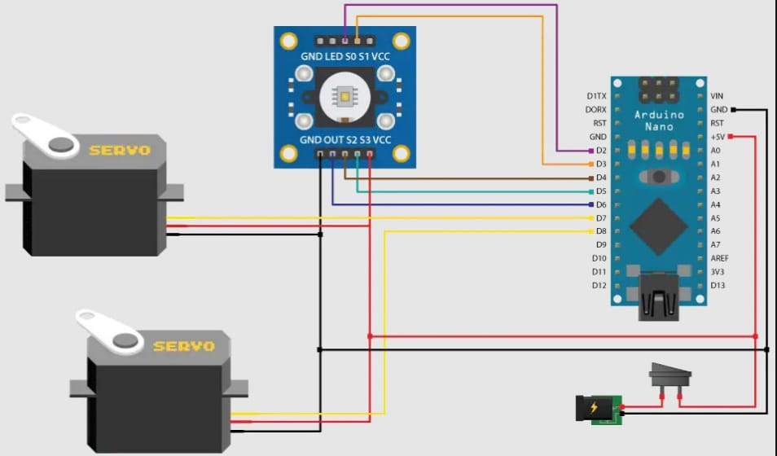

Fig. 3. Circuit Diagram of Automated Clothes Segregator

Fig.4 shows the working prototype model of Automatic Clothes Segregator

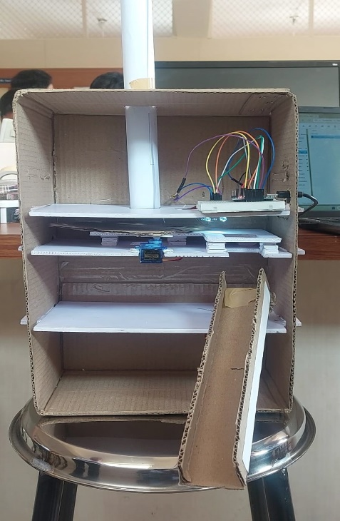

Fig.4. Working prototype model of Automated Clothes Segregator

The servo motor is seamlessly integrated into the system, with specific connections to the Arduino Nano to ensure optimal functionality. Its VCC pin is linked to the 5V pin on the Arduino Nano, providing a consistent power supply. Meanwhile, the GND pin is connected to the ground pin for proper grounding. The servo motor’s control signal is intricately tied to a PWM (Pulse Width Modulation) pin, typically designated as pin 9 on the Arduino Nano. This arrangement allows for precise control over the motor’s movements.

During operation, the Arduino Nano receives input signals from sensors, often indicating the type of clothing detected. Based on this input, the Arduino Nano sends a corresponding signal to the servo motor through the control pin. As a result, the servo motor rotates to a predefined position, activating a mechanism configured for sorting clothing items. This streamlined and automated setup enhances efficiency and accuracy in various sorting applications.

**Discussion**

The system demonstrates effective color-based clothing classification. By accurately identifying colors, it mitigates issues like color bleeding and fading in textiles. We’ve also addressed sensitivity to ambient light and the need for regular sensor calibration. Future research can explore advanced sensor technologies and machine learning algorithms to enhance color detection and classification accuracy, overcoming existing limitations.

**Conclusion**

This project presents a comprehensive solution for automating clothing sorting based on predefined criteria. By integrating servo motors controlled by an Arduino Nano microcontroller, we achieve precise sorting operations in response to input signals. The meticulous connections between the servo motor and the Arduino Nano ensure reliable functionality, with optimized power supply and signal transmission for seamless operation.

The project’s significance lies in its potential to streamline sorting processes across various industries, including logistics, retail, and manufacturing. With the Arduino Nano serving as the central controller, the system demonstrates adaptability and scalability, making it suitable for diverse operational settings. By harnessing servo motor technology and microcontroller capabilities, our project underscores the power of automation in enhancing workflow efficiency and precision.

Future refinements and enhancements could further expand the project’s functionalities, solidifying its role as a valuable asset in modern automation and sorting systems.

**References**

1. M. S. Surbakti *et al.*, "Development of Arduino Uno-Based TCS3200 Color Sensor and Its Application on the Determination of Rhodamine B Level in Syrup,"*Indonesian Journal of Chemistry*, vol. 22, no. 1, p. 630, Apr. 2022, doi: 10.22146/ijc.69214.
2. "Arduino Based Color Sorting Machine using TCS3200 Color Sensor,"*International Journal of Innovative Technology and Exploring Engineering*, vol. 8, no. 6S4, pp. 1259–1261, Jul. 2019, doi: 10.35940/ijitee.f1258.0486s419.
3. P. A. Harsha Vardhini and G. Janardhana Raju, "Design of Internet of Things Based Smart and Efficient Water Distribution System for Urban and Agriculture Areas,"Journal of Computational and Theoretical Nanoscience, vol. 17, no. 9, pp. 4688–4691, Jul. 2020, doi: 10.1166/jctn.2020.9301.
4. Sachdeva, "Development Of Industrial Automatic Multi Colour Sorting and Counting Machine Using Arduino Nano Microcontroller and TCS3200 Colour Sensor," The International Journal of Engineering and Science, vol. 06, no. 04, pp. 56–59, May 2017, doi: 10.9790/1813-0604025659.
5. "Design And Fabrication Of Weight Based Product Sorting Machine,"Strad Research, vol. 8, no. 5, May 2021, doi: 10.37896/sr8.5/031.
6. Sandra, R. Damayanti, Y. Hendrawan, B. Susilo, and S. Oktavia, "Prediction of tomatoes maturity using TCS3200 color sensor,"*IOP Conference Series: Earth and Environmental Science*, vol. 475, no. 1, p. 012011, Apr. 2020, doi: 10.1088/1755-1315/475/1/012011.
7. N. Jain, Y. Awasthi, and R. K. Jain, "An IoT-based soil analysis system using optical sensors and multivariate regression,"*International Journal of Experimental Research and Review*, vol. 31, no. Spl Volume, pp. 23–32, Jul. 2023, doi: 10.52756/10.52756/ijerr.2023.v31spl.003.
8. R. Nayak, A. Singh, R. Padhye, and L. Wang, "RFID in textile and clothing manufacturing: technology and challenges,"*Fashion and Textiles*, vol. 2, no. 1, Jun. 2015, doi: 10.1186/s40691-015-0034-9.
9. Sandra, R. Damayanti, and Z. Inayah, "Nitrogen Fertilizer Prediction of Maize Plant with TCS3200 Sensor Based on Digital Image Processing,"*IOP Conference Series: Earth and Environmental Science*, vol. 515, no. 1, p. 012014, Jun. 2020, doi: 10.1088/1755-1315/515/1/012014.
10. T. T. Nguyen, T. T. Nguyen, V. T. Nguyen, C. C. Cao, and J. Hua, "Application of Arduino Control Mainboard with Color Light Sensor TCS3200 in Color Recognition of Edge Banding In Laser Edge Banding Machine,"*IOP Conference Series: Earth and Environmental Science*, vol. 252, p. 022130, Jul. 2019, doi: 10.1088/1755-1315/252/2/022130.
11. L. Alboteanu and F. Ravigan, "Automatic Sorting System for Educational Training,"*Annals of the University of Craiova Electrical Engineering Series*, vol. 46, pp. 42–48, Dec. 2021, doi: 10.52846/aucee.2022.07.
12. "Arduino Based Color Sorting Machine using TCS3200 Color Sensor,"*International Journal of Innovative Technology and Exploring Engineering*, vol. 8, no. 6S4, pp. 1259–1261, Jul. 2019, doi: 10.35940/ijitee.f1258.0486s419.
13. P. J. Tarwadi and A. S. Arockia Doss, "Vision Based Pick and Place Robot for Sorting Objects Using MATLAB,"*Applied Mechanics and Materials*, vol. 592–594, pp. 2314–2318, Jul. 2014, doi: 10.4028/www.scientific.net/amm.592-594.2314.
14. S. Vandana, K. Shamukha Sri Sai, P. Rohila, and V. Manideep, "PLC Operated Colour Based Product Sorting machine,"*IOP Conference Series: Materials Science and Engineering*, vol. 1119, no. 1, p. 012016, Mar. 2021, doi: 10.1088/1757-899x/1119/1/012016.
15. "The 2022 IEEE International Symposium on Industrial Electronics [Society News],"*IEEE Industrial Electronics Magazine*, vol. 16, no. 3, pp. 81–84, Sep. 2022, doi: 10.1109/mie.2022.3190981.
16. Ba. Anandh, "IOT based Automated Object Colour Sorting and Counting System,"*International Journal for Research in Applied Science and Engineering Technology*, vol. 7, no. 3, pp. 594–598, Mar. 2019, doi: 10.22214/ijraset.2019.3103.
17. R. Ciobanu, D. Rizescu, and C. Rizescu, "Automatic Sorting Machine Based on Vision InspectionAutomatic Sorting Machine Based on Vision Inspection,"*International Journal of Modeling and Optimization*, pp. 286–290, Oct. 2017, doi: 10.7763/ijmo.2017.v7.599.
18. S. Krishnakumar, K. Sneha, and A. Reethika, "Review on Sensor based Colour Sorting Robot for Candy Manufacturing,"*IOP Conference Series: Materials Science and Engineering*, vol. 1084, no. 1, p. 012094, Mar. 2021, doi: 10.1088/1757-899x/1084/1/012094.
19. K. Friedrich, "Sensor-based and Robot Sorting Processes and their Role in Achieving European Recycling Goals - A Review,"*Academic Journal of Polymer Science*, vol. 5, no. 4, Feb. 2022, doi: 10.19080/ajop.2022.05.555668.
20. K. Arsenopoulos and P. Benardos, "A Human-Robot Interface for Industrial Robot Programming using RGB-D Sensor,"*Procedia Manufacturing*, vol. 55, pp. 9–15, 2021, doi: 10.1016/j.promfg.2021.10.003.